**ARE DEVOUT PEOPLE SOCIALLY NONCONFORMIST?**

-Vansh Mehta, BVCOE

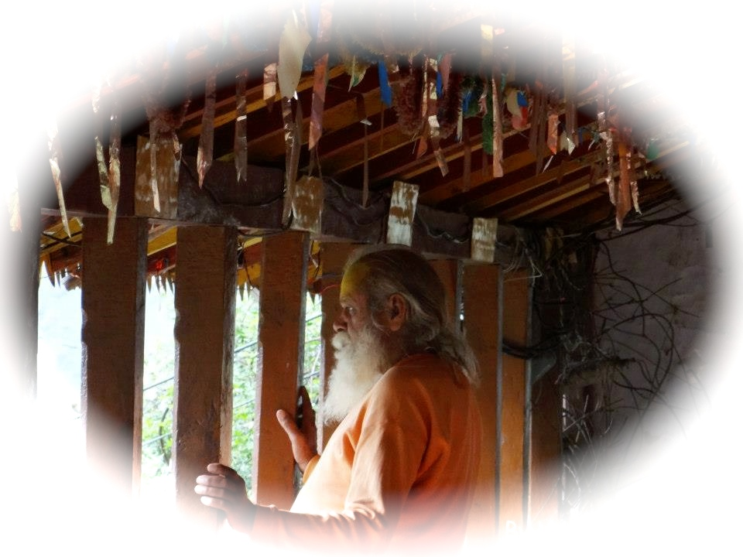

The worldly often views a religious person as distant, dogmatic and lacking in intellectual insight. In our spiraling materialistic tendencies, the devout are often ridiculed and believed to be inept in social context. By virtue of their faith, they are tagged as backward and conservative. The materialist tends to be presumptuous and thinks that a religious person won’t drink or smoke, is irrational and orthodox. Hence pious people are looked upon as societal misfits.

If, for instance, a religious person achieves a major position somewhere, he is regarded as odd and an annoyance to those around him because he refuses to take bribes! In schools and colleges, some students wear prominent religious marks on their foreheads and their classmates take pride and delight in mocking and degrading them. Sometimes he (or she) may even be physically attacked for his religious beliefs.

The life of a religious person is not easy. He has to look for a path that allows him to follow his values in an environment that is constantly trying to pull him down. The mundane person, in comparison, is a social chameleon who ceaselessly changes his color to match his surroundings. In a second, he can turn from capitalist to communist, companion to foe, Jekyll to Hyde. He has no ethics, beliefs or goals, except those that are conducive to his crude bodily inclinations.

However, the pious person understands that though he may be a social misfit, others are misfits of a different kind. They are transcendental misfits. The 'religious social loner' knows that one day, the world will turn to his way of thinking. He sees everybody as being essentially spiritual, they having become corporeal only superficially.

The more we broaden our horizons - even on the materialistic level - the more spiritual we become! It is only when we narrow ourselves and our horizons, that we become ordinary and dull. Today, everyone is a misfit. You have to find out which one you are and which one you want to be - social or spiritual.

